DISTRIBUTION LINES DESIGN

Mechanical Consideration

TRANSMISSION SYSTEM DESIGN DIVISION 1
PROVINCIAL ELECTRICITY AUTHORITY

Distribution Lines Design

Contents
- Poles
- Guying and anchor
- conductors and cables

PEA’S distribution system includes low voltage – 230/400 volts and medium voltage- 22 , 33 kv system. Since the beginning of the last decade, some customers have their plants operated at 115 kv voltage level , so this could be regarded as distribution system due to its function.
However, we will exclude consideration of 115 kv lines design and focus on low and medium voltage lines design mechanically because it contributes large portion of the whole systems. Also we limit the scope to overhead lines design, which are commonly used in Thailand.

Design Criteria is referred to when the part of distribution systems is being considered.

1. Poles
Prestressed concrete poles are commonly used in distribution lines. The rectangular shaped cross-section of the pole is increasing from the bottom to the top. Along the length of a pole, a round steel bar. or a galvanized steel wire is embedded to provide ground path and also nut’s holes are provided for fixing pole’s assemblies such as crossarms , transformer’s beams etc.
Prestressed concrete poles used conventionally in PEA’s distribution systems are as below :
For 22, 33 kilovolts lines:
12 meters long are common for single on three phase’s feeder.
14 meters long are used for three phase feeder, one or two circuits on the same pole.
For 400/230 volts lines:
8 meters long are used for single-phase feeder
9 meters long are used for single or three phase feeder, are or two circuits on the same pole.

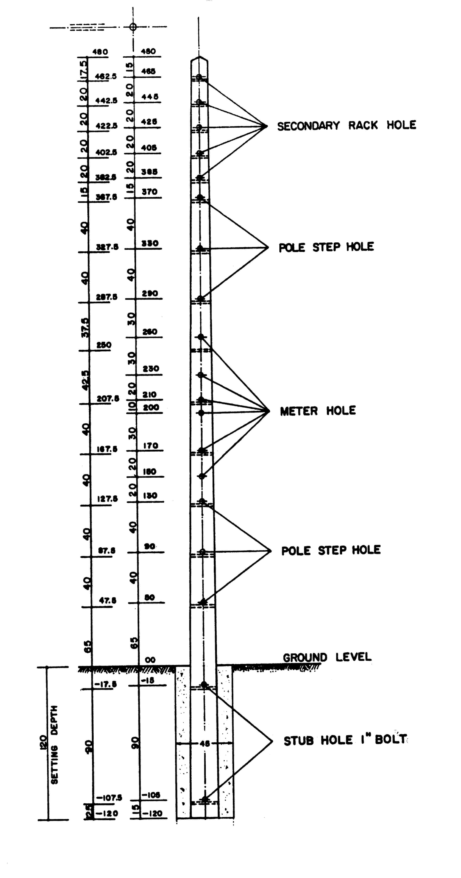

Prestressed concrete pole

Design consideration
Prestressed concrete poles while serving their function are subjected to mechanical loads. They will be broken down if the bending moment caused by the mechanical loads overcome their capacities. Thus, it is very important to examine the capacity of poles during a design process.
Sources of bending Moment
1) Wind load
Wind load will cause bending moment on 3 components.
  - poles (BMp)
  - conductors or cables (BMc)
  - other equipments installed on pole such as crossarms insulators etc.
2) Eccentric load
Weight of conductors , cables and other equipments installed on the pole can caused bending moment. However, for distribution systems, the significant sources of bending moment are conductor or cables and insulators.
3) Bending Moment caused by conductor or cable’s tension.
On angle poles, the tension in conductors or cables will cause bending moment.
After determination of bending moment from all mentioned sources has been done, the total bending moment on pole will be compared to the capacity of the pole.
By definition:
Bending Moment (BM) = F X H
Where F = Applied force to pole and its members. (Kg)
And H = Distance from ground to the point where force applied.(m)

Example: A Pole with 1 meters long is fixed at point A. Then we apply 2 kg of force at point B as shown in Fig 1.

To calculate bending moment on pole:
BM = F X H
= 2 x 1 kg - m
= 2 kg - m
Calculation of Bending moment
- Bending Moment caused by wind Load
  - wind striking on pole
BMp = W_{P} × CG (kg – m)
where W_{P} = wind force on the direct side of the pole (kg)
CG = distance from ground level to center of gravity of pole’s portion above ground.(m)
= 0.004 V² × A_{P}
(V = wind velocity in km/n, 96 km/n is a typical value in Thailand and A_{P} = surface area of the direct side of pole.)

  - wind striking on conductors
BMc = Σ Bm_{ci}
Bm_{ci} = Bending Moment caused by conductor i
= W_{ci} × H_{i}
where w_{ci} = wind force strikes on conductor for one span length.
= 0.0025 V² × d × L
(V = wind velocity in km/h, d = outer diameter of conductor i and
L = distance between two adjacent poles)
Hi = distance from ground level to the conductor i
- Bending moment caused by eccentric load.
Cables which are attached directly to poles will not caused this kind of bending moment. For those cables and conductors stringing on insulators at some distance far from poles horizontally, bending moment must be calculated.
  - Weight of cables and conductors.
BM_{ec} = W_{c} × L × l × n
Where W_{c} = weight of conductors or cables (kg)
L = distance between two adjacent poles (m)
l = horizontal distance from pole to cables or conductors being
considered.
n = number of cables or conductors
  - Weight of Insulators.
Bending moment caused by Insulators may be neglected due to their small weight and short distance from poles. However, for high voltage lines , the bending moment should be taken into account.
- Bending Moment caused by conductor or cable ‘ s tension.
BM_{sa} = 2xT Sin α /2 x h x n
Where α = line deflection angle (degree)
T = conductor or cable tension (kg)
h = distance from ground level to cables or conductors (m)
n = number of cables or conductors.
Note : In case the tension has been reduced, then
T = WL² /8S
Where W = cables or conductor ‘ s weight.
L = distance between two adjacent poles.
S = sag of cables or conductors.

2.Guying and anchor
For deadend or angle poles, tension caused by conductors must be compensated by appropriate guying method.
The guying components are:
1. Guy wire
Steel stranded wire with zinc coated, varying in size, maximum pulling strengths and maximum allowable pulling strengths are in use in distribution system. Size of guy wire may be specified either in length of diameter or cross-section area and number of strand are mostly 7.
2. Preformed guy grip and clamp
Their components are used for fixing one end of guy wire to pole and another to anchor.

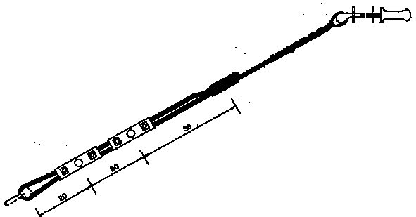

3. Strain insulator
For safety reason, a strain insulator put in serie at some distance of guy wire will prevent human being and animal from possible leakage current.
4. Guy guard
To protect guy wire from any mechanical damage. A lower part of it may be covered by guy guard.
5. Anchor
This part of guying is embeded beneat the soil and connected to guy wire.
Three types of anchor are commonly used.
  - Swamp anchor
This type of anchor will be applied in soft soil. Maximum holding value is not greater than 4000 lbs.

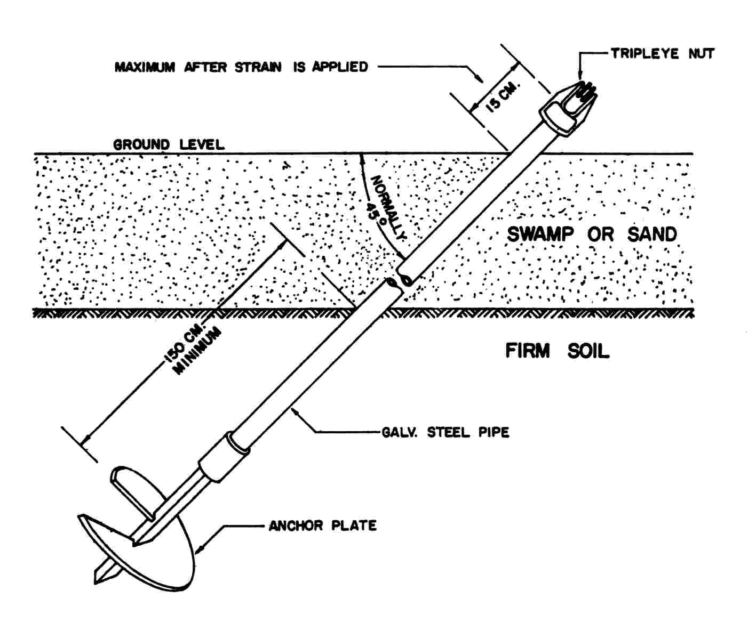
swamp anchor

  - Log anchor
A cylindrical shape with 12 inches diameter and 1.5 meters long, could
withstand maximum holding value up to 15000 lbs.
Concrete in cubical shape may also be used instead of log anchor.

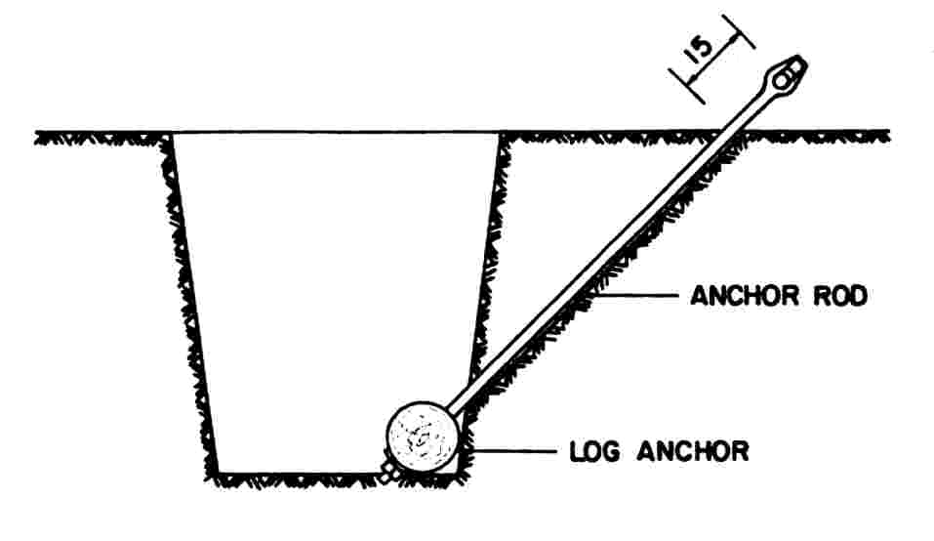
Log anchor
  - Stub – anchor
This type of anchor will be applied in wet and soft area such as canal
pond etc.
  - concrete plate
For general condition of soil , PEA applys this type of anchor in its
systems.

Type of Guying
Guying can be named after their physical installation.
1) Span guy or Head guy.

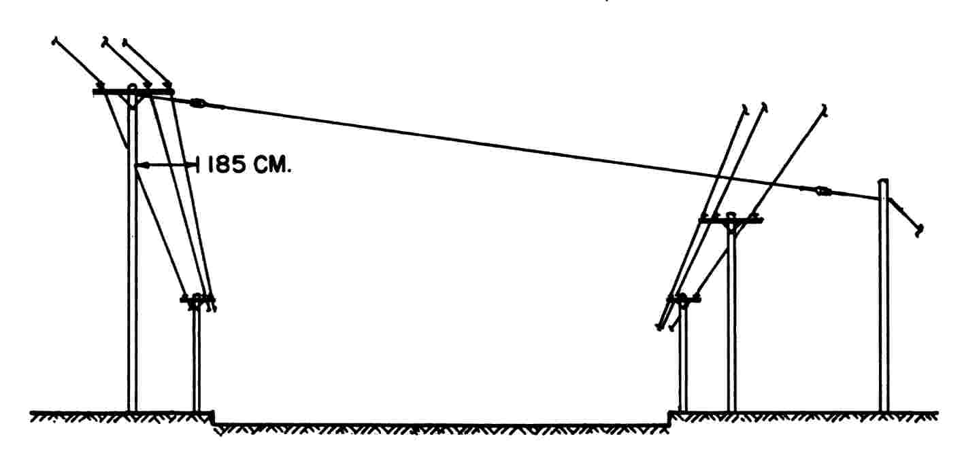

Span guy

2) Arm guy.

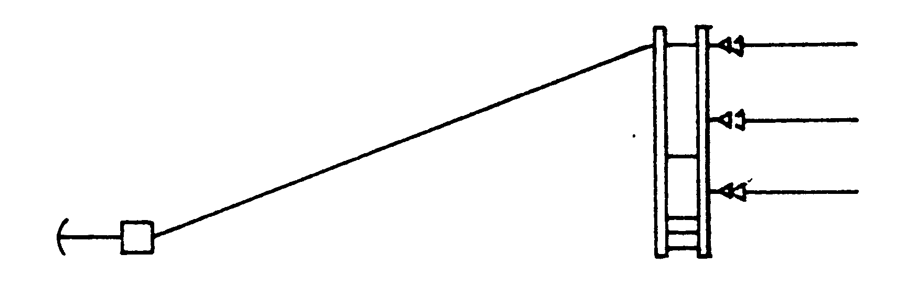

Arm guy

3) Down guy.
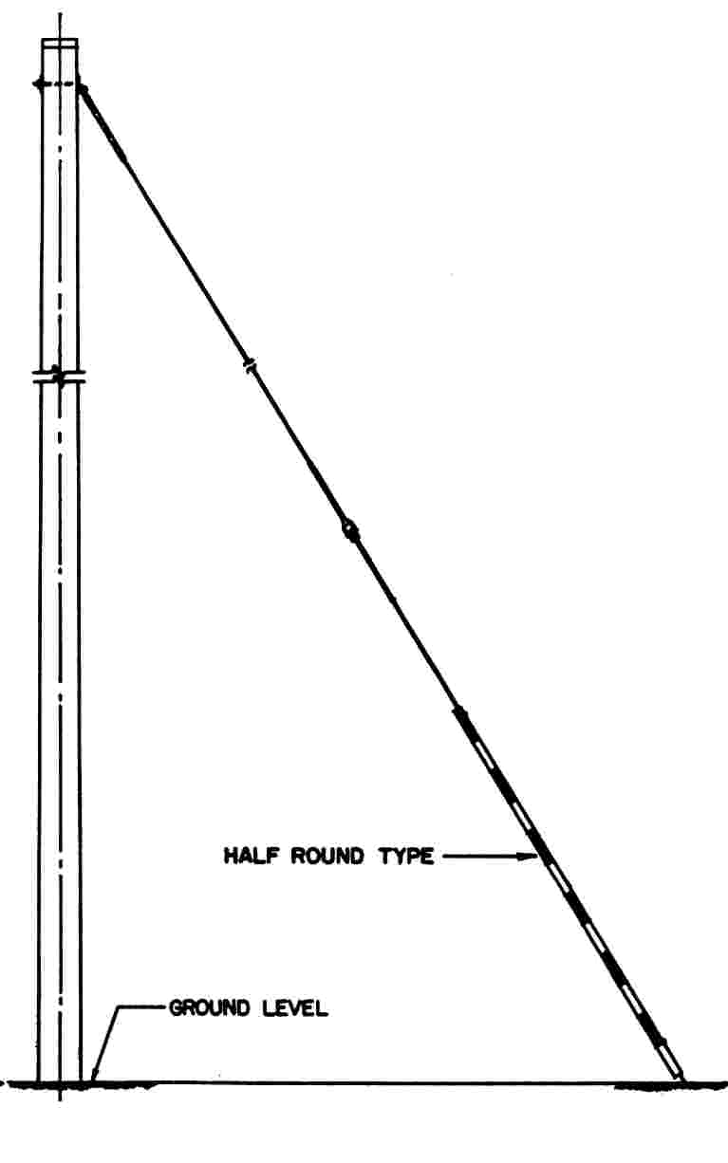
Down guy
4) Sidewalk guy.

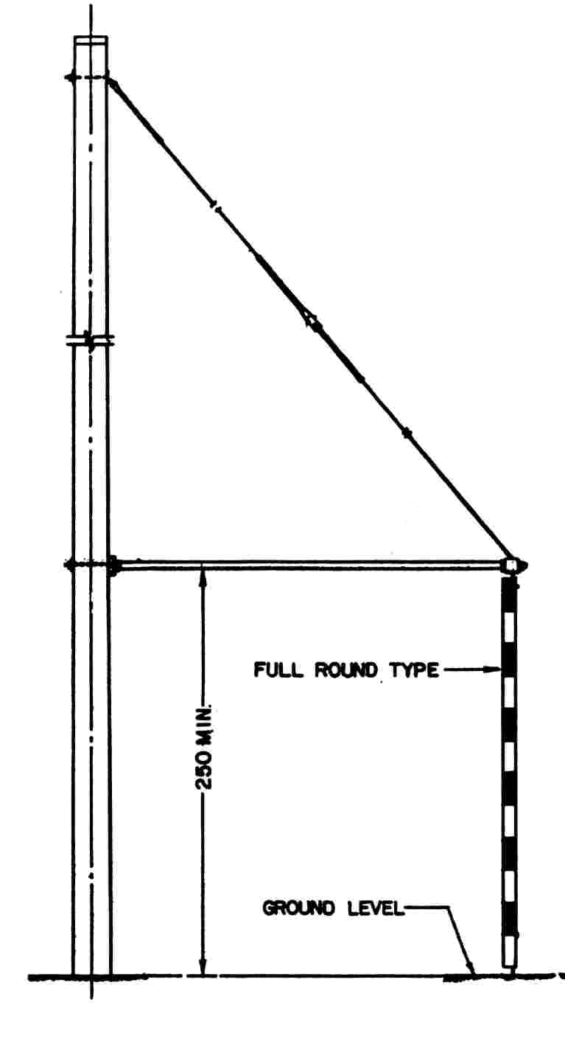
Sidewalk guy

Design Consideration
To determine the size of guy wire and apppropriate anchor, methods can be done either by calculation or by nomographic diagram. For the sake of conceptual understanding , The calculation method is exhibited here.
Steps 1: Determine conductor tension applied on pole (T_{R})
T_{R} = 3T
Where T = maximum design tension of one conductor.
Step 2: Determine guy wire pulling tension, (T_{G})
T_{G} = T_{R} secα
Step 3: Choosing an appropriate size of guy wire from a standard table.
Step 4: Choosing an appropriate anchor.

Example: Three aluminum conductor, 120 mm² in cross-section area each, are fixed to the top of concrete pole, and a guy wire is to be fixed as shown in Figure below. Determine size of wire and appropriate anchor.
(Maximum design tension of the conductor is 1,240 lbs.)

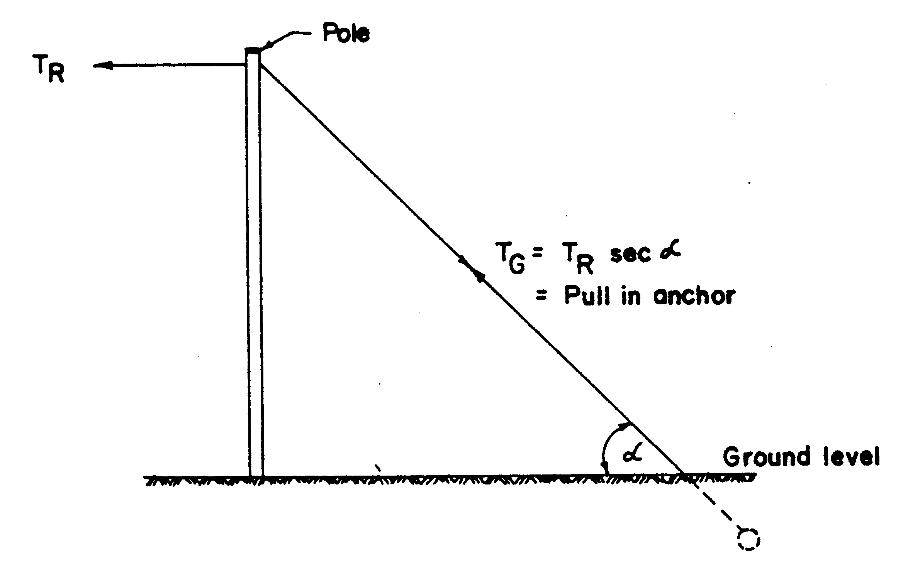

Step 1: Determine conductor tension applied on pole. (T_{R})
T_{R} = 3T
= 3 x 1,240 lbs.
= 3,720 lbs.
Step 2: Determine pulling tension Inage wire. (T_{G})
T_{G} = T_{R} sec α
= 3,720 x sec 45°
= 5,261 lbs.
Step 3: Choosing an appropriate size of guy wire.
From table, an appropriate size of guy wire is 3/8-inch diameter with maximum pulling tension of 6,500 lbs.
Step 4: Choosing an appropriate anchor
From table, Log Anchor is chosen.

In case where Log anchor or cubical shape concrete anchor is applied, soil capacity should be examined since it contributed significantly to success of guying.

Note:
Pulling tension in guy wire can be replaced by a vertical and horizontal force, produced by anchor. When soil capacity is greater than the vertical and horizontal forces produced by anchor, the anchor will stay at the same position. Some factor may be needed for safety reason.

Stub anchor Cubical concrete anchor

Calculation of soil resistance in vertical direction.
- Stub anchor
F_{V} = F x A x L
Where F_{V} = soil capacity (kg/m²)
A = boundary length of stub anchor’s cross-section
area.
L = length of stub anchor embedded in soil (m)
- Cubical concrete anchor.
W = (B² + B₁² + B (B₁)) γ H/3
Where B₁ = B + 2H tan φ
H = distance from ground level to centroid of anchor
γ = soil density which the value is between 1500 kg/m³ and 1800 kg/m³ for soil below underground water level and the value of 1,000 kg/m³ could be used for soil above underground water level.
φ = angle of repose (30° for general soil and 5°-10° for soft soil)

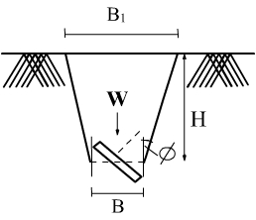

Calculation of soil resistance in horizontal direction
- Stub anchor
Due to complexity, calculation must be done by computer program. However simple calculation can be done by the some formula under 2)

- Cubical shaped anchor
Soil resistance in horizontal (P_{P}) = γ HA k_{P}
Where γ = soil density (kg/m³)
H = distance from ground level to centroid of anchor (m)
A = area of anchor’s surface that contact to soil in horizontal
direction.
k_{P} = tan² (45º + ∅/2)

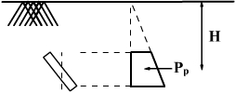

3. Conductors and cables
The only two kinds of materials used worldwide as electrical conductor are copper and aluminum. Comparison between the two , copper is better for conductivity and pulling tension withstanding. But Aluminum is dominate when taking cost into consideration. This is the reason why aluminum is cammonly used as conductor for overhead distribution lines in this region. However, copper is applied more for underground power cables where insulation cost is also taken in to account.
Conductor may be in a solid or strand form due to its application. For a larger size of conductor, stranded conductor is more appropriate for stringing or wiring. Thus, all of low and medium voltage distribution lines make use of stranded conductor.
Moreover, Stranded conductor could be produced as ordinary stranded, or compact stranded as shown in figures.
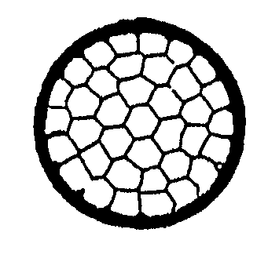
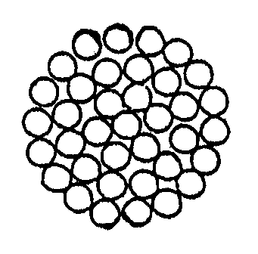
Ordinary stranded compact stranded

Conductor’s cross-section area or conductor’s size may be in square millimeter (mm²), circularmill (CM) or mega-circularmill (MCM) unit.
1 cm is equal to area of a circle of 1/1000-inch diameter.

1/1000

Application of conductor
Medium Voltage distribution lines ( 22, 33 kV.)
1. All Aluminum conductors: AAC
This type of aluminum conductor is bare and stranded. The conductor can be applied where ruling span between 2 adjacent poles is not longer than 80 meters approximately.
2. All Aluminum Alloy Conductors: AAAC
The conductor is made of aluminum mixed with other substance such as magnesium in order to increase tensile strength and weight of the conductor. I t is very practical to use this type of conductor where the distribution lines is not more than 1 Kim far from the sea.
3. Aluminum Conductor Steel Reinforced: ACSR
To Improve All Aluminum Conductors’ tensile strength, stranded steel wire is added. The conductor is very appropriate where longer span is needed.
4. Spaced Aerial Cable: SAC
In the area where installation of bare conduction is not possible due to limited space such as town on city, then SAC is a good solution.
The cable is made of stranded aluminum covered with XLPE insulation. Thus, it can be compact by using spacer at a certain interval along the lines.

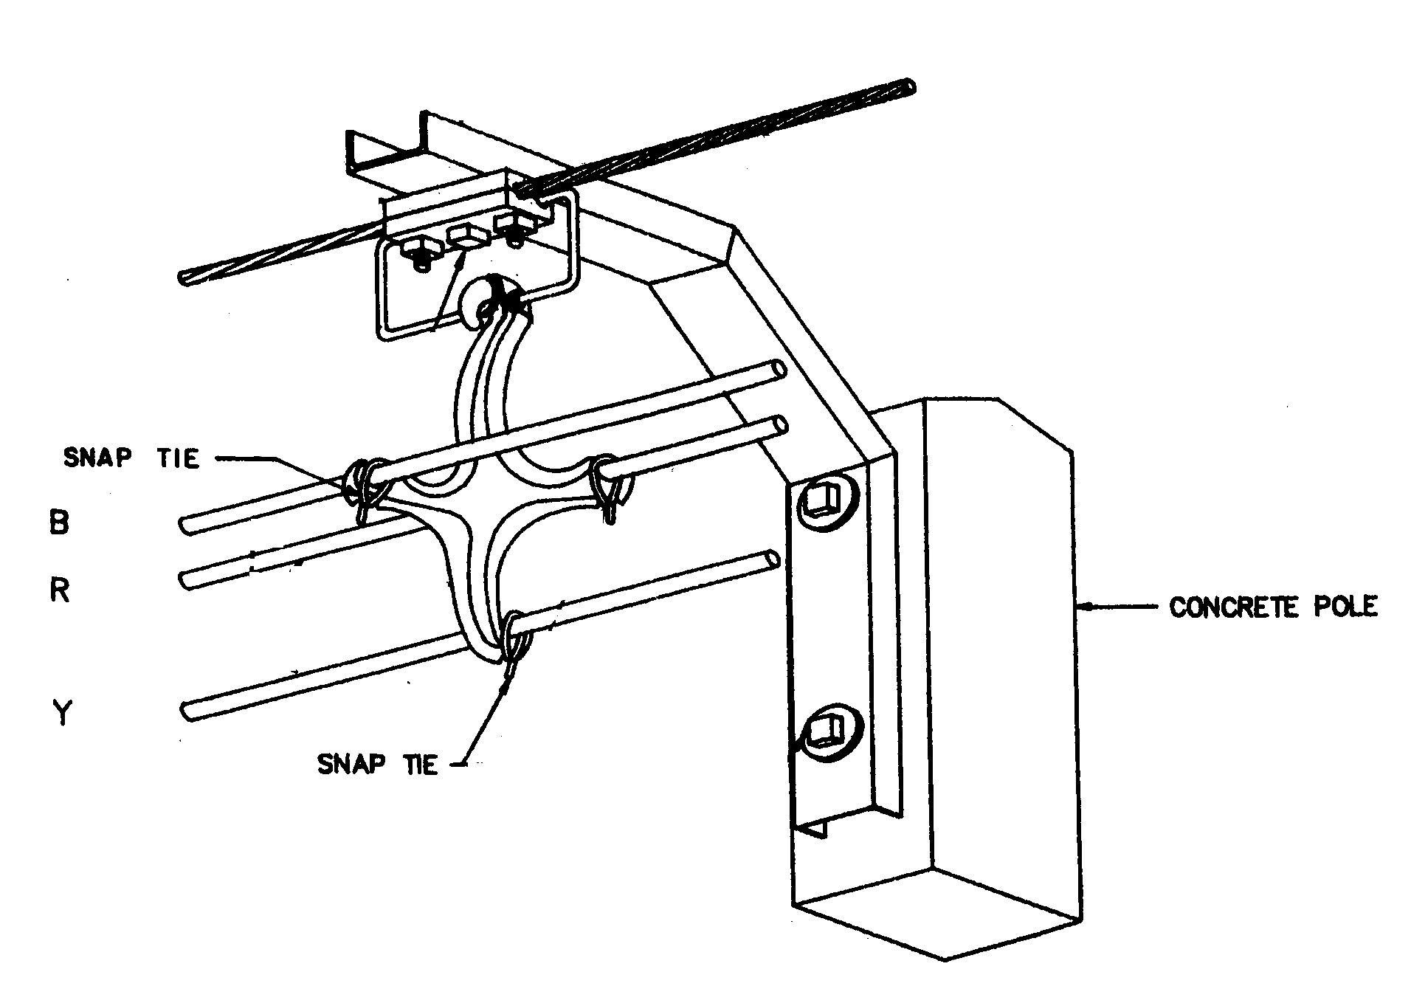
SAC installation

Low voltage distribution line (400/230 volts)
1) Weatherproof Aluminum Conductor: AW
The cable is made of compact, stranded aluminum conductor insulated with polyethylene (PE) or polyvinyl chloride (PVC).
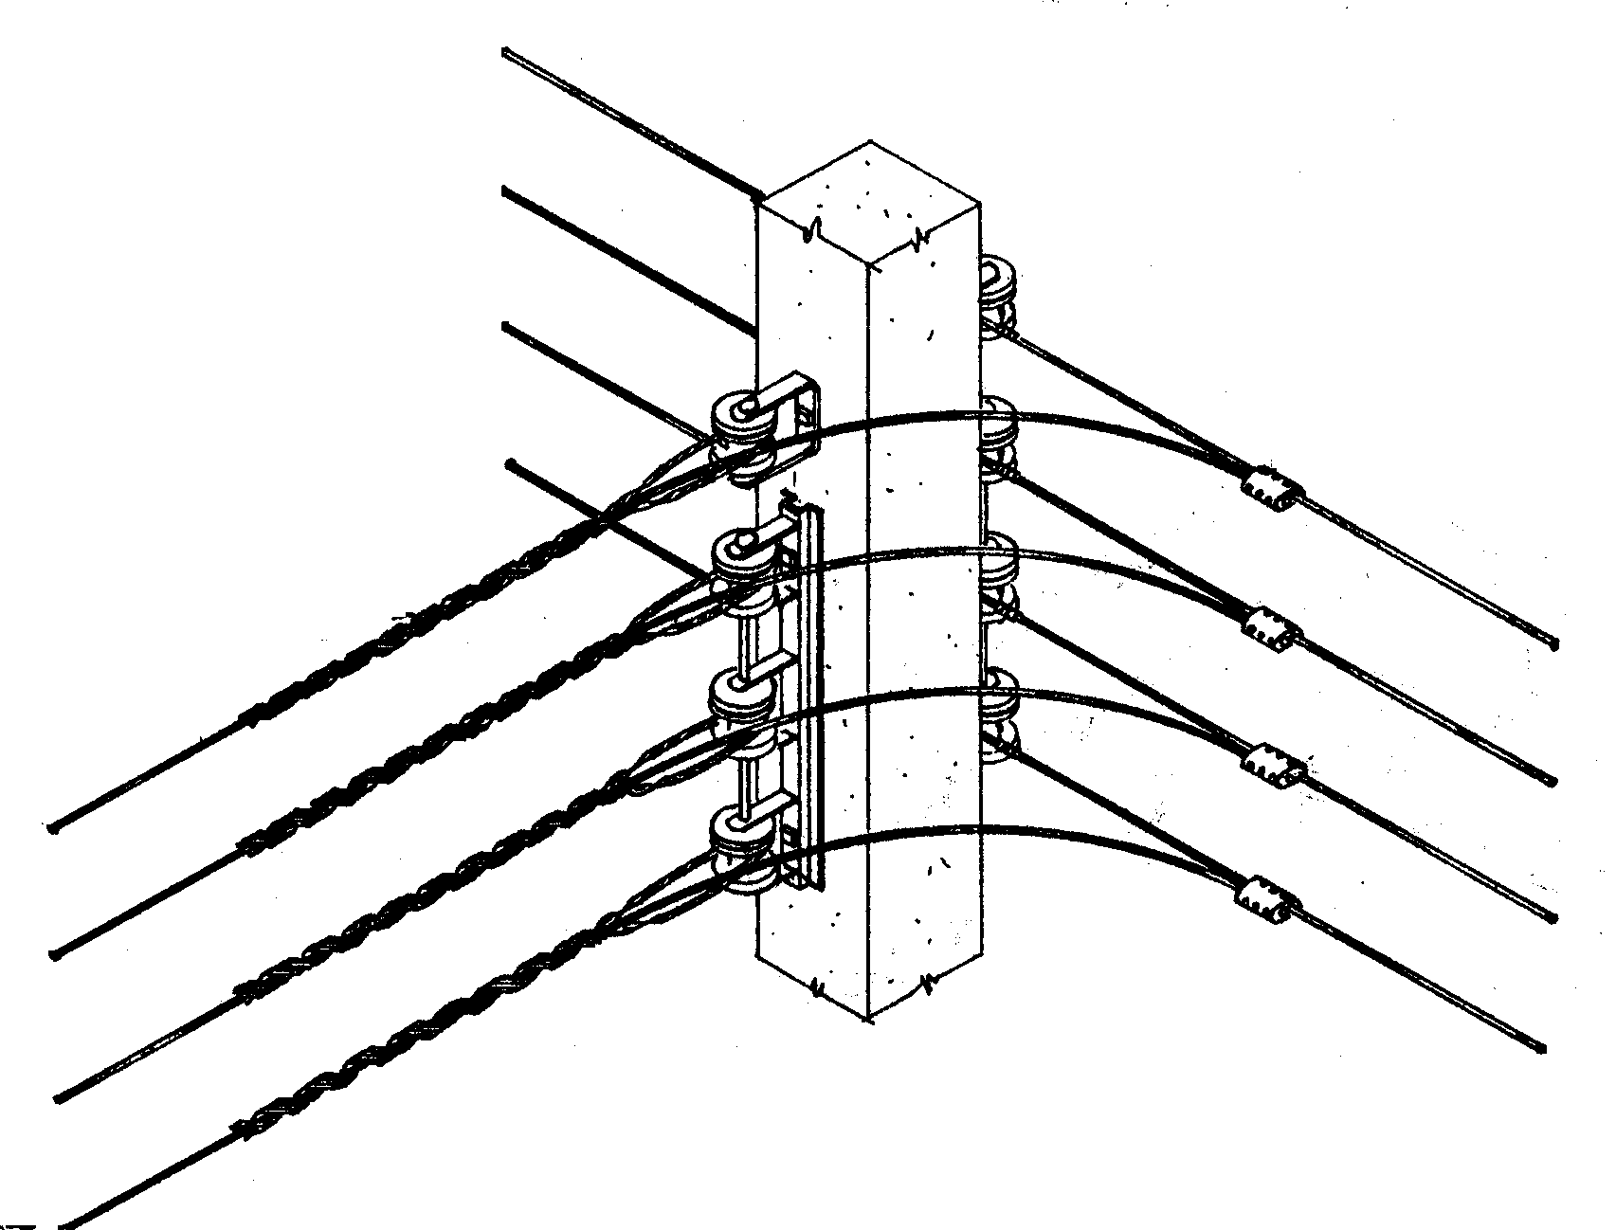
This type of cables is commonly used outdoor in both MEA and PEA’s distribution lines, However, PE is famable substance and shall not be used indoor.
Installation of AW conductor
- Self – supporting service Drop Cable or Multiplex Cable.
1, 2, 3, or 4, compact stranded aluminum conductors, insulated with cross – link polyethylene (XLPE) and galvanized steel wire,acting as a neutral, twisted together to form this type cable.
The cable is designed to use as a service drop to building, road crossing for short distance.

Design Consideration
During design stage, after the distance between two adjacent poles has been determined, then, sag – tension must be examined to ensure that all three conditions below are fulfilled.
1. Tension at maximum load is not greater than 60% of conductor’s breaking strength.
2. Initial unloaded tension at 60°F is not greater than 33.33% of conductor breaking strength.
3. Final unloaded tensions at 60°F is not greater than 25% of conductor’s breaking strength.

Sag-tension calculation
To calculate sag-tension, two practical formulae are :
D = WL²/8T and
T2³+T2²[AE(W1²L²/24T1²+α(t₂-t₁)-T1]-AEW2²L²/24 = 0
Where E = modulas of elasticity (kgf/mm²)
A = cross-section area of conductor (mm²)
- = coefficient of linear expansion (/ºC)
t₁ = temperature at a first point of time, (ºC)
t₂ = temperature at a second point point of time.(ºC)
W = weight of conductor per unit length (kg/m)
W1 = weight of conductor at a first point of time. (kg/m)
W2 = weight of conductor at a second point of time. (kg/m)
L = span length (m)
T = tension (kgf)
T1 = tension at a first point of time (kgf)
T2 = tension at a second point of time (kgf)
D = sag (m)

