Greater Mekong Sub-region (GMS) Power market perspective – experience from international power market

By Tuan NGUYEN (IED)

1. Fundamentals of (de)regulation and operation of power market

Power market is a system created for exchange, trading in electricity commodities and services. Before analysing the power market, we have to present the definitions of different market such as bilateral markets, exchange markets and pool markets. Bilateral markets, where buyers and sellers trade directly or facilitated by a broker, provide a private coordinating mechanism which are reasonably efficient at providing the bulk power supply, but they are too slow to provide efficiently real-time balancing and transmission security. Also negotiating and writing contracts is expensive as well as credit worthiness risk is large. Exchange markets provide a public, centrally determined, market price. At any given time and location, exchange market pays the same price to any generator selling power. Exchange is inflexible, provides security for traders, reduces trading cost and increases competition. Pool markets provide a price, side payment and instructions on which generators should start up. In effect, pool market pays different prices do different suppliers at the same time and location. Generators bid their marginal cost and certain other cost and limitation into the market, which computes a prices and a set of accepted bids. Some accepted bids are found to lose money because the market price is lower than their marginal cost. The market makes up for this by granting accepted bidders a side payment that makes them whole.

1.1 Regulation and deregulation of power sector

Power sector has undergone several restructuring vague in its history. In the beginning of the power production in United States, there was wild and inefficient competition. Then it was understood that power sector is a natural monopoly and it should be regulated. Integrated power utilities remained natural monopolies for many decades and required regulations or public ownership.

Regulated and vertically integrated utilities were well established but as transmission system developed, it was able to transmit power over long distance thus new possibilities for trade and competition. The developed transmission network allows the deintegration of power sector.

During the 1990s, there was a vague of power transformation in many countries. This restructuring process has an objective to move the sector from a monopoly structure to a more competitive one. Under restructuring and deregulation, vertically integrated utilities which group all generating, transmission and distribution of electricity, have been unbundled into different independent activities.

The competition has been introduced in the generation by the creation of a market, which allows several generation companies to compete to sell their electricity in a power pool or through bilateral agreement with buyers. Retailing activities, where customers can choose among different generating utilities or buy directly from the market, have been implemented. It rests transmission and distribution activities that are considered as natural monopolies that require regulation to ensure open access to the transmission network for all market’s buyers and sellers. Currently, more than a dozen deregulated electricity markets are operating in deferent countries with different degree of openness and competition.

1.2. Restructuring and deregulation conditions

Because of monopoly nature of power sector, regulations are needed to set the tariffs, which allow the utilities to pass the costs (return on investment) and earn a reasonable profit. The regulated tariffs have little incentive to reduce the costs or to invest in new production facilities. On other side, regulatory bodies themselves do not have proper incentives.

The role of deregulation is to restructure the power sector into a competitive market to yield economically efficient solution, to eliminate monopoly power, and to archive lower prices to customers. There several reasons that push the regulations bodies to restructure and deregulate power utilities (Rothwell & Gomez, 2001) :

- New generation technologies, such as CCGT, have reduced the optimal size of an electricity generator;
- The competitive global economy requires input cost reduction; electricity is a primary input for many industries;
- The government, as owner and manager of traditional infrastructure industries, can not respond as quickly as private owners to economic and technological change, prompting privatisation;
- Information technologies and communication systems make possible the exchange of huge volumes of information needed to manage electricity markets;

Although deregulation process takes place in many countries with objectives to promote economic efficiency and reduce the customer’s costs, economic regulation must be use where the perfect market competition is not feasible, for example in sector that have natural monopoly characteristics or in situation where existent externalities. Traditionally, the power sector is considered as a natural monopoly. Under deregulation, only transmission and system operations show evidence of natural monopoly characteristics, which requires the regulation by: i) government ownership; or ii) private ownership with government regulation, taking into account comparative social costs and benefits.

1.3. Governance of power market

Governance is the process by which decisions get made, implemented and enforced – it is internal to the market. In contrast, regulation is how government reviews and changes the decisions of market – it is external to the market. There is trade-off between governance and regulation : an effective system of self-governance can eliminate the need for extensive government regulation. Four basic governance models have been analysed by James Backer et al. (1997) :

Model 1. A Multi-Class Stakeholder Board

A multi-class stakeholder board is the club or legislative approach to governance. In its governance structure, most or all classes of users and owners are represented on the governing board. It is designed for collective, self-governance by all who participate in the market. Collective governance tries to achieve independence through voting allocations and rules that attempt to balance the often-conflicting interests of different classes. It has been described as "independence by diffusion," but will fail to achieve independence if one company or one class has the voting power to block actions that everyone else supports.

Model 2. A Non-Stakeholder Board

A non-stakeholder board tries to achieve independence directly. The board is not meant to be a representative board. Board members are explicitly prohibited from having current or future financial interests in any market participants. The goal is to create a board that will represent the broader "public interest," not the commercial interests of any particular market participant. Board members are usually required to have professional qualifications and experience that are relevant to the activities of the pool. The principal danger of a non-stakeholder board is that it can become isolated and politicised. To minimize this problem, some market combines Models 1 and 2 in a two-tier approach to governance.

Model 3. A Single Class Board

In a single class board, one class controls decision-making. This has been the historic model for most of the old style tight power pools that have operated in the United States. It is also the current approach in Chile where the largest pool is effectively a club of large generators. Single class domination can be achieved directly by simply limiting voting membership to a one class. It can also be achieved indirectly by giving independent decision-making authority to committees dominated by one class or by allowing the favoured class to select "independent" board members who are not really independent.

Model 4. A Single For-Profit Corporation Not Affiliated With Market Participants

Most power pools around the world are organized as non-profit associations or corporations owned or controlled by some or all market participants. An alternative is to create a single for-profit corporation not affiliated with any market participants. If this approach is adopted, governance becomes an internal corporate matter for the profit-making corporation.

1.4. Power market operation

Power market operation has been evolved over time. The old style power market were created to improve reliability, to minimised operating cost through cost-based dispatch and to accommodate control of decision making by the vertically integrated, large participants. In contrast, the new style pools were created to maximize competition in generation (subject to accepted reliability standards), to compete on price, not cost and to be open to all market participants.

Table 1 : Two style pools (Source : Backer J. et al., 1997)
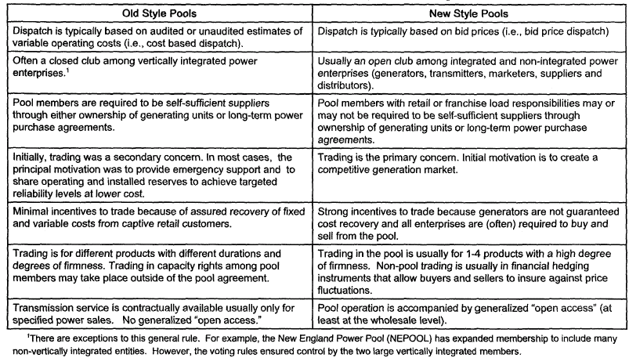

Trading for the power delivered in any particular time begins years in advance and continues until actual time in which the power flows out of a generator and into a load. This is done by a sequence of overlapping markets. Forward markets are financial markets in the sense that the delivery of power is optional and the seller’s only real obligation is financial. If power is not delivered, the supplier must purchase replacement power or pay liquidate damages. In many forwards markets, traders need not own a generator to sell power.

Spot markets are physical markets; It usually means real time market as all trades correspond to actual power flows. In a competitive market, the real-time prices are true marginal cost prices, and forward prices are just estimates. Any power that is sold in the future market but not delivered in real time is deemed to be purchased in real time at the spot price of electricity. This is called a two-settlement system.

Under this new structure of generation and transmission with competitive trading, power market operation have been defined and separated into i) Market operations concerned power trading, scheduling, settlement of power transactions and will be performed by Market Operator (MO); and ii) System operations concerned operation and control of the power to assure system real time dispatching, to maintain system reliability and security, and to manage transmission congestion which are manipulated by System Operator (SO).

In a market, MO and SO can be independent entities or joint unit. If the market allows wholesale competition only, the buyers are distribution companies who buy bulk electricity and resell to customers. If the market allows retail competition, buyers could be any individual (customers, retailers, distributors…)

Market holds an auction in which each generator bids different prices for different quantities of power for a given trading period. Based on the bids and considering demand, the market operator uses a matching process to set the market price and generation quantities. Buyers can also bid quantities and prices, which are ranked in demand curve by decreasing prices. The intersection of the supply and demand curves are founds and the prices of the last generator schedules becomes the market price. This price is known as the market clearing price, the price that all sellers will get and that all buyers will pay.

Market clearing price can vary dramatically depending on load variations and put the market participants in a risk under this new deregulation. To reduce the market uncertainty and fluctuations, buyers and sellers make contracts that specify prices and supplies in advance through contracts for differences, a financial instrument (it does not involves a physical power transaction) that guarantees a price and a quantity between the seller and the buyer that protect them from fluctuations.

2. Experiences from Nord Pool power market

Actually more than a dozen deregulated power markets are operating in different developed and developing countries. In spite of this rapid success, many fundamental problems remain or arise from these experiences. This paper does not attempt to analyse the problems but will try to present the most relevant experience from GMS power market perspective – International Nordpool power market.

2.1. Raison d’être

Nord Pool is the world’s most developed international power market, which has been evolved from the old model of multilateral exchange among the vertically integrated utilities in each Nordic country to competitive market.

Differences in generation mix largely explain the establishment of interconnections in Scandinavia. Norway relies entirely on hydro (nearly 100%, the remainder is based on thermal power), while Denmark generates all power in thermal plants, mainly from imported coal. Sweden has a mix of about half hydro and half nuclear generation, and Finland a mix of hydro (25 percent), conventional thermal (45 percent), and nuclear (30 percent) plants. The power market is fairly large: together, the four countries consume about 360 terawatt-hours (TWh) a year, surpassing the U.K. market. The differences in generation structure have made it economically attractive to trade power, allowing the countries to optimise production.

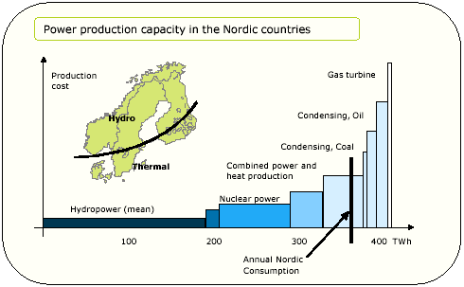
Figure 1 : Power generation structure in the Nordic countries (source : Nord Pool).

2.2. Before deregulation

Before the restructuring happening, power sectors in Norway, Sweden and Finland had an oligopoly structure, in which the governments or public authorities take the control as major shareholders, though there were differences in structure, ownership and regulation.

Norway's power sector was dominated by the government-owned integrated utility Statkraft, which also operated the national grid. There were also many small local and regional utilities. Between fifty and sixty companies, many owned by local or regional authorities, were involved in the transmission of electricity at the regional level. The local and regional utilities had gained access to the national grid in 1969 and could buy and sell power through a spot market. About 200 companies, many of which were owned by municipalities, distributed electricity locally.

In Sweden about half the generation was government-owned through Vattenfall, which also operated the national grid and provided distribution services in parts of the country. About ten other integrated utilities of various sizes also used the national grid, but a relatively high network fee made it uneconomical for smaller utilities to use it. Like Norway, Sweden had a large number of distribution companies (presently about 250), many owned by municipalities.

In Finland the state-owned Imatran Voima Oy (IVO) was the largest utility. IVO also operated the national grid. Much of the power generation was owned by Finnish industries, however, which formed a transmission company, TVS, to interconnect their generation and supply areas.

2.3. Deregulation and restructuring in Nord Pool’s countries

Norway introduced deregulation in power supply in 1991 through the Energy Act aiming at: i) avoid excessive investment; ii) improve selection of investment projects; iii) create incentives for cost reduction through competition; iv) avoid cross-subsidy between customer groups; and v) reasonable geographical variation in prices. Transmission system of the state-owned power company Statkraft, was separates into a new national grid company Statnett SF. Third-party access was introduced to all network levels, and vertically integrated company had to adopt separate financial accounting for generation, distribution and supply activities. In addition, retail access was introduced for all customers, including small residential customers. A Norwegian power pool known as Statnett market (later renamed to Nord Pool) was established as a subsidiary in 1993.

In Sweden reform was fuelled by discontent among the private power companies stemming from Vattenfall's control of the national grid, and dissatisfaction among the smaller power companies and among customers over their lack of access to the market for occasional power. The first major step, taken in 1991, was to corporatize Vattenfall's generation and distribution activities. Vattenfall remains government-owned, however. The national grid was retained as a government owned institution, Svenska Kraftnat, which also serves as the system operator. The networks were gradually opened to new players, and a new electricity act allowing a competitive market finally took effect in January 1996.

Finland introduced new energy legislation in 1995. IVO had already separated its grid activity into a separate company, IVS. But with the privately owned grid company TVS, Finland had two overlapping grid companies for several years. Since September 1997 Finland has had a single, merged grid company, Fingrid, which also acts as the system operator.

2.4. Nord Pool market governance and operations

Trading of electricity between the countries was enabled through Nordel, an organization set up in the 1960s to promote cooperation among the largest electricity producers in each country. Nordel was based on the principle that each country would build enough generating capacity to be self-sufficient. Trading was meant to achieve optimal dispatch of a larger system-and investment in interconnection was generally based not on net exports but on expected savings from pooling available generating capacity. The countries exchanged information about their marginal cost of production. When there was a difference, trading took place, at a price that was the average of the two marginal costs. The cost-plus structure in the Nordic power sector led to over-investment in the power sector and poor return on equity. But because the system retained a degree of competition, there were no significant operating efficiency problems in the utilities.

Norway led the way in reform, opening up a spot market in 1992. A similar power market in
Sweden would have been difficult to manage, as Vattenfall and Sydkraft, the two largest generating companies, together control about 75 percent of generating capacity. But the Norwegian market also experienced problems. Because all the power in Norway is produced by hydroelectric plants, the spot market price was very volatile. A combined Norwegian-Swedish market would address the problems of both countries. A decision was therefore made to establish a joint electricity trading exchange in January 1996, with a design based on the Norwegian experience. The grid operators own the company, Nord Pool that organizes the market. Finland joined the power exchange in June 1998.

Thus, the Norwegian regulator largely regulates the Nord Pool market even though it is an international market. The market is owned by a profit making corporation rather than a non-profit corporation or association. Statnett and Svenska Kraftnat, the main grid companies, are owned by the government of Norway and Sweden respectively. They in turn each own 50 percent of Nord Pool SA, the market operator. Four of the nine seats on the Nord Pool board have been set aside for market participants and a market council of users has been created to provide advise to the board. The Nord Pool, therefore, represents a mixed case that combines collective and corporate governance.

Table 2 : Power of Regulator and Government (source : Barker J et al., 1997
Regulator | Norwegian Water resources and energy Administration
Must approve all proposed changes before they become effective even if no one appeals | Notified of proposed changes
Pool rule changes
Prerequisites for appeal/complaint to regulator | None
Can unilaterally make changes | Yes
Regulator’s decisions appealable | Yes to Ministry of Industry & Energy
Board composition
Approves appointments | Regulator – no  Government – yes
Makes appointments | Regulator – no  Government – yes
Can change voting rules and allocations | No
Pool prices | No but can refer to competition agency
Market surveillance
Formal market surveillance group operated by regulator or pool | No
Regulators’ access to information | Very substantial

Nord Pool organised two different markets for trade in power: Elspot (the spot market) and Eltermin (the futures and forwards market).

Elspot market trades in hourly contracts for next day physical delivery on an auction basis. It is open to all companies that have signed the necessary agreements with Nord Pool. On Elspot, hourly power contracts are traded daily for physical delivery in the next day's 24-hour period. Elspot's price mechanism is used to regulate the flow of power where there are capacity restrictions in the Norwegian grid and between the various countries. Thus, Elspot may be viewed as a combined energy and capacity market. A market clearing price par MWh is determined for each hour during the next day by construction of aggregated supply and demand curves from participants bids and offers. This trading method is referred to as equilibrium point trading, auction trading, or simultaneous price setting.

Eltermin market is a futures market for cash settlement of a specified volume of power at a negotiated price, date and period. The contracts are trades as weekly four to seven week ahead, as blocks of four weeks up to fifty-two weeks ahead, or as seasons (Winter 1 for weeks 1-16, Summer for weeks 17-40, and Winter 2 for weeks 41-52) up to three years ahead. The system price (Elspot price) is used as a reference price for these contracts.

Beside the two market organized by Nord Pool, Finnish EL-EX organized an intermediate two-hour ahead market. This market allows the Swedish and Finnish participants the opportunities to adjust schedules closer to the hour of operation.

In addition to these markets, there is direct trading between parties in bilateral contracts. These bilateral contracts are normally for physical deliveries and treated the same way as spot power, i.e. scheduled with the Nord Pool. The reason for this is that Statnett needs a continuous overview of the total power flow to manage congestion.

2.5. Sector structure and ownership lessons

Sector structure is important because it limits what governance and regulation can accomplish. Governance and regulation may success in establishing market and system operators that are independent of market participants, but they may fail to establish competitive market if the underlying structure does not support competition or operators lack necessary operational control and enforcement power. The smooth transition to the international power market has been thanks to long tradition of cross-border bilateral trade and cooperation and the existence of cross-border transmission structure.

The experiences from Nord Pool shows that setting up the power market did not requires privatising public owned utilities. Different ownership, including cross-ownership between countries, companies continue to operate generation, transmission and distribution systems, but ownership of international interconnection system has been transferred to the grid company in each country. That paves the way for trading to all the parties in the power market.

In addition to the traditional power company, other parties can trade on the market including brokers, oil company, foreign power company and power trading companies representing consumer groups.

2.6. Competitive

Though the Nord Pool market has strict regulation of the network service to ensure that third-party access, it is less regulated compared to other power markets. Because the Nordic countries already had a large number of players so the market is largely assumed to be able to take care of itself under the supervision of national regulation authorities.

There are also some particular points of the Nord Pool in terms of competition. The Nord Pool is a market for both sellers and buyers. Another difference is that the generators in the Nordic system are not obligated to sell all their power to the market. So to keep business from going elsewhere, the Nord Pool must ensure that it is an attractive market.

Retail competition which allows the customers to change suppliers also solved. Market access without hourly metering system is possible for small customers through a method of estimated load profiles for specific areas rather than customer-specific load profile in invoicing and settlement.

3. GMS power market perspective

3.1. Power structure in GMS

Generation mix in GMS countries is quite different. Laos is entirely relies on hydropower, with only few genset served as reserve. Cambodia actually relies almost on thermal power but it has great potential in hydropower development. Vietnam hydropower assures nearly 50% of its demand in the present as well as in the future, while Thailand relies almost exclusively on thermal generation and import purchase (95%).

Table 3 : Generation mix in GMS countries in 2001, GWh (sources : Annual reports).
 | Cambodia | Laos | Vietnam | Thailand
Hydro |  | 1 578 | 18 207 | 6 310
Thermal  - Coal  - Gas  - Oil | 174 | -  -  0.5 | 3 213  4 406  3 325 | 17 306  34 871  3 268
IPP & Purchase | 241 | - | 1 449 | 41 409
Total | 415 | 1 579 | 30 600 | 103 165

By the year 2015, the countries in the region will have great potential power exchange, as great hydro potential in Laos, Cambodia and Vietnam will be exploited. Most of addition thermal capacity will be constructed in Vietnam and in Thailand and hydro capacity will be added in Laos, Vietnam and in some extent in Cambodia. Together, this market would be represent 150 millions persons and more than 300 TWh of electricity consumption per year in 2015.

3.2. (De)regulation and organizational structure in GMS

3.2.1. Power Sector Restructuring in Electricity of Vietnam (EVN)

At present, EVN is a state-owned body responsible for the whole chains of power system: production – transmission – distribution. In the future, the national energy policy envisages to introduces gradually restructure and deregulation in three stages :

In first stage up to 2005, an independent – accounting mechanism will be introduced as pilot programmes for some power generating plants and power production-sale to transmission companies is to be carried out with transferred prices under the control of National Load Dispatch Central. The objective is for utilities to lead the initiative in production costing and lowering losses, implementing accounting mechanism based on profits, facilitating capital mobilization and diversifying ownership of investment. Issuance of transfer pricing mechanism (including capacity and energy charges) of each utility will be introduced gradually in each generating power plant with independent production costing business operating mechanism.

Transfer pricing mechanism will be implemented within 3-5 year period (depending on reform mechanism of the Government and the success of the implementation in each utility). In transmission activities, EVN will still implement procedures of generation and transmission sectors on centralized accounting basis. Transmission companies will be in charge of management of power transmission expansion projects. Distribution companies will purchase electricity from EVN and sell to consumers and be responsible for investment in distribution networks. Besides EVN distribution companies, establishment of independent distribution companies in the forms of stock holder, private or joint-venture will be encouraged.
In the second stage between 2006 and 2010, EVN independent-accounting power plants will compete with independent power producers, selling bulk power to transmission companies based on Power Purchase Agreement under the regulation of National Load Dispatch Central. All power plants will operate according to independent accounting mechanism, produce and sell electricity to power transmission companies at transfer prices.

Reorganize transmission sector into single unified transmission body, splitting from generation, accounting based on profits, operate as independent utility under the financial and cost effective control of EVN.

Integration of all transmission companies and dispatch centre into single state owned transmission company managing transmission lines with voltage level of 220 kV and above.
The Transmission Company will purchase power from generating power plants and sell to distribution companies and directly to big consumers.

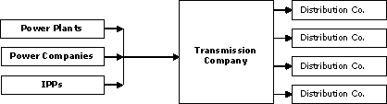
Figure 2 : Competition in both production and distribution in 2006-2010 (source : EVN)

In third stage after 2010, the government will establish a power pool (see figure below). During this period, IPPs and BOT power plants will participate into competitive power market and hourly pricing mechanism will be applied to reduce production cost and the selling tariffs.

Commercialisation and marketization of the distribution sector will start also at this stage. Distribution companies will be restructured and classified into bulk and retailing. Distribution companies will purchase electric power via power pool and may select customers through Power Purchase Agreements. Government will still manage Transmission Company in line with economic development strategy.

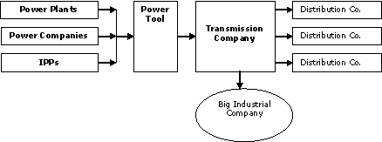
Figure 3 : Vietnam Power Pool after 2010 (Source : EVN)

3.2.2. National Policy on Power Development in Thailand

The reform process in Thailand power industry has been commenced from 1992, base on the promulgation of the Royal Act on Private Sector Participation in State Affairs. In the same year, the power supply industry has been opened to the power purchases from IPP and SPP (Small Power Producer).

In the short term, the government of Thailand has a firm policy to accelerate the implementation of these domestic power purchases as formerly announced and to go on with the announcement of the next phase of power purchases. The privatisation of power supply industry will be carried out in parallel with the purchasing of power from the private sector. The privatisation is aimed to increase efficiency in administration, investment and personnel development. However, EGAT (Electricity Generating Authority of Thailand) remains to be the sole purchasing utility and transmission of electricity. SPP, IPP and EGCO (A subsidiary corporation unit of EGAT who controls 2000 MW of EGAT capacity) sell electricity to EGAT who in turn sell high voltage electricity to distributors and some large customers. SPP are allowed to sell directly its electricity to end-users. Metropolitan Electricity Authority (MEA) and Provincial Electricity Authority (PEA) are responsible for the distribution and retail services, but they are under direct control of the Prime Minister Office as state enterprises through their respective EGAT Act, MEA Act and PEA Act.

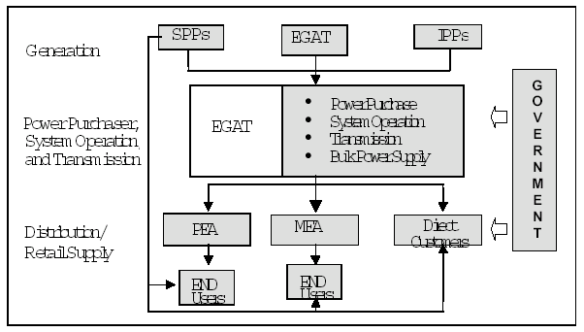
Figure 4 : Actual power structure in Thailand (source : EGAT)

In the future, several activities has been planned as:

- Regulation : establish an independent regulatory body, promulgate regulatory framework and market rules for the power pool.
- Generation : Generation business will be corporatized into three subsidiaries : Power Generation 1, Power Generation 2 and Hydro Generation.
- Transmission : A power market will be created with independent system operator. EGAT continue to operate the grid company. The transmission system will be finally transformed into a common carrier to enable the customers to have free choices on selecting the electricity suppliers that meet their requirements.
- Distribution : several electricity delivery company (DISCO) will be created and retailer could participate in market.

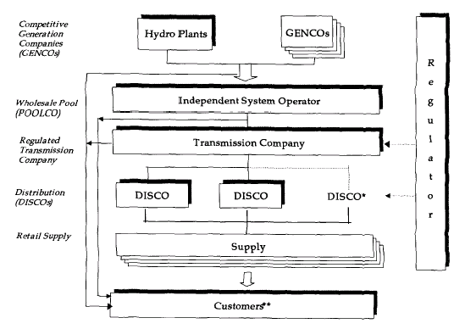
Figure 5 : Restructuring and deregulation in Thailand power industry in future (source : EGAT)

Under the current policy on energy development, the government of Thailand has emphasized the cooperation with Thailand's neighbouring countries in the areas of power development and power purchases as well as to speed up the restructuring of power supply industry and the acquisition of power from IPP and SPP.
For the policy on energy development with neighbouring countries, the purchasing of power from Lao PDR will be increased to 3,000 MW. The interconnection of transmission systems among the six countries in the Mekong Basin sub-regional group has also been addressed in the national policy. The joint development of hydropower projects in the Mekong and Thailand Basins will be encouraged so that the sale of power to Thailand can be realized.

3.2.3. Restructuring of the Electricité du Cambodge

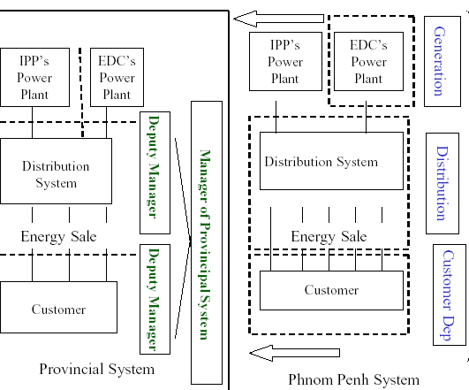
Figure 6 : Current EDC structure (source : EDC)

Future Structure
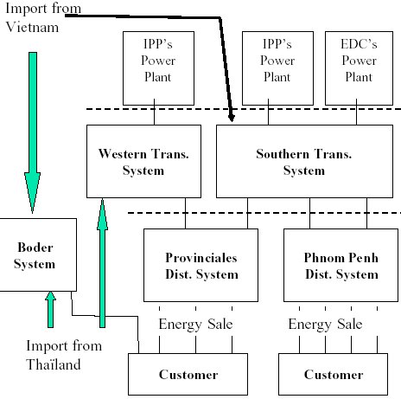
Figure 7 : Future structure of EDC (source : EDC)

3.2.4. Restructuring of the Electricité du Laos

EdL is a state-owned corporation under the Minister for Industry and Handicrafts which owns and operates the country's main generation, transmission and distribution assets in Lao PDR, and manages electricity imports into its grids and exports from its stations. EdL also has a project development role and has been the implementing agency for government hydropower power projects and in the case of IPP projects is the Government's shareholder. It has been past practice for EdL to take over from MIH the responsibility for a project once a shareholders' agreement is executed and the project loans are closed.

Currently, no restructuring and deregulation processes are envisaged. However, there is a need for coordinated strategies and overall power planning procedures, comprising both the national (domestic) sector and the export sector. The primary objective of such coordinated power sector planning should be to achieve lowest possible net electricity supply costs for the national grid (net, after crediting benefits from power export). A National Energy Agency probably will be established over the DoE and EdL, which is responsible for establishing and updating a coordinated power plan. The plan would form the binding framework for all future power development in Lao.

3.3. Interconnections between GMS countries
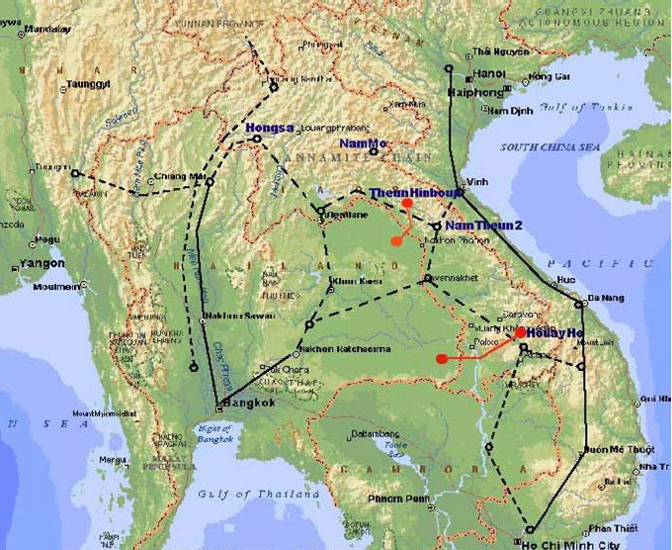
Figure 8 : The actual and future HV GMS Power Grid (source : HAPUA)

3.3.1. Interconnection between Laos and Thailand :

There are existing interconnection in 230 KV and 115 KV from Laos to Thailand.
From | To | Voltage, kV
 |  | Installed | Operated
Nam Theun Hinboun P.S. | Nakon Phanom (EGAT) | 230 | 230
Houay Ho P.S. | Ubon Ratchani 2 (EGAT) | 230 | 230
Phonetong S.S (Vientiane) | Udon Thani 1 (EGAT) | 115 | 115
Phonetong S.S | Udon Thani 2 (EGAT) | 115 | 115
Thanaleng S/S (Vientiane) | Nongkhai (EGAT) | 115 | 115
Pakxan | Boungkan (EGAT) | 115 | 22
Thakhek | Nakhon Phanom (EGAT) | 115 | 22
Savannakhet (Pakbo) | Mukdahan 2 (EGAT) | 115 | 115
Bang Yo (Pakse) | Sirindikhom HPS/ Ubon Ratchathani (EGAT) | 115 | 115

The current Agreements (MOU) between the Government of Laos and the Governments of Thailand and Vietnam provide for the export of an additional 3,300 MW to Thailand and of 1,000 MW to Vietnam during the next ten years, and generation planning of the three countries is currently based on the eventual availability of these generating capacities.

Interconnection Plan

- The establishment of a Lao National Grid Company, which is able to export and to exchange power with neighbouring grids of Vietnam, Thailand, Yunnan (China) and Cambodia.
- The implementation of the 500 kV line to export power from the Nam Ngum basin projects to Thailand. Finalization of transmission interconnection arrangements for other IPP such as NamTheun basin projects.
- Planning for a 500 kV transmission line in southern Lao PDR to export power from the Sekong basin projects to Vietnam and interconnection with Thailand. A joint field survey for S/S location for the 500 kV interconnection from southern Laos to central Vietnam has been carried out early 1999. Further details on implementation will be discussed between both utilities as soon as the field survey report is submitted.

3.3.2. Interconnection between Vietnam and Laos

Actually, there are no connections at transmission voltages to Vietnam (only 35 kV). The Ministry of Industry approved the Interconnection Master plan between Laos and Vietnam on February 2002. Interconnection between Laos and Vietnam will be pursued as follows:

- Southern Lao to Central Vietnam: Transmission line 500 kV from 500kV substation in Southern Laos to 500 kV substation Pleiku in Central Vietnam, receiving power from hydro power plants on Se Kong river for supplying` to Vietnam.
- Central Lao to Central Vietnam: Transmission line 500 kV from 500kV substation in Central Laos to 500 kV substation Ha Tinh in Central Vietnam, receiving power from hydro power plants on Nam Theun river for supplying to Vietnam.
- Transmission line 220 kV from HP Nam Mo (in Lao PDR) to HP Ban La (in Vietnam). By now, EVN negotiation with Developer of HP Nam Mo to buy energy from this project.
- Transmission line 220 kV from HP Se Kaman 3 (in southern Lao PDR) to Da Nang (in central Vietnam).

3.3.3. Interconnection between EVN with Cambodia

The power cooperation agreement with Vietnam was signed on 10th June 1999. The supply of power to the areas along the border by medium voltage line and interconnection between high voltage links is planned.

Vietnam is supplying energy to some districts near border between two countries.
The 220 kV transmission lines supply to Phnom Penh which will be commissioning in the year 2004. At present, EVN approved FS of feasibility study on part this interconnection in Vietnam territory, from Thot Not to the border at Tinh Bien village (about 90 km). EVN' Consultancy company are carrying out designing of this transmission line.

3.3.4 Interconnection between Cambodia and Thailand

The medium voltage at level 22 kV links along the border are already in place. Recently, an agreement was reached with Trat Province (Thailand) on power supply to Koh Kong Province (Cambodia) and Poi Pet (Cambodia) and some other areas along the border of Cambodia and Thailand.

The power cooperation agreement with Thailand was signed on 3 February 2000. The agreement provides a framework for broader cooperation on power trade, technical assistance, and open access to third parties. It encourages joint utilization of their indigenous energy resources.

Electricité du Cambodge, Ministry of Industry Mine and Energy and Electricity Generating Public Holding Co., (ECGO, Thailand) signed the contract on 5 April 2000 for feasibility study of the power interconnection with Thailand to Banteay Meanchey, Siem Reap and Battambang.

The Power Purchase Agreement (PPA) and the Implementation Agreement (IA) are being discussed and to be signed separately within this year. The project is expected for commissioning in late 2002.

3.3.5 Interconnection between Cambodia and Laos

Actually there is and no connections at all to Cambodia. Export to Cambodia could be an economic proposition on a small scale such as Tha ko (30MW) HPP in border areas. EdL is planning a single 115 kV transmission line from Ban Yo 115 kV substation (Laos) to the Laos-Cambodia border which has a length is about 150 km. This project aims to expand electrification in the southern province of Lao PDR and supply to Cambodia’s demand around the border area and further to Strung-streng (Cambodia).

4. Conclusions: capacity building and learning

From the analysis presented, we can see that actually there is bilateral power exchange at small scale between GSM countries. In the medium term, these power trades will become large-scale bilateral power exchange. But to become power market in its proper term, there would be long way to go for GMS countries as there are many issues remained.

The World Bank study "Power Trade Strategy for the Greater Mekong Sub-Region" concluded that numerous benefits were linked to interconnected networks in the GMS, including: lower costs, improved quality of supply and reduced emissions of greenhouse gases and other pollutants. The report concluded that a cooperation trade scenario could save around 10 billion US$ over the next two decades. In the near future, financing needs for power expansion and adherence to market economy would be driving force behind restructuring and privatisation in GMS countries, rather than inefficiency concerns. First objective of the GSM interconnection would be an old style pool (see above) which is likely to be more relevant to GMS that are pursuing an incremental approach to power sector reform.

The Nord Pool power market probably is not a suitable model in short-term for GSM countries just beginning to move from a traditional government-owned monopoly utility to a more market-oriented structure in near future. Nevertheless, Nord Pool demonstrates the possibilities of an international power market, an attractive option in long-term for GMS countries with small power systems and different generation mix.

International regulatory is also a difficult issue to the national sovereignty, because regulatory responsibility has to be divided horizontally among equals rather than vertically among higher and lower level government authorities. The Nord Pool is a unique example with relatively smooth national (Norwegian) regulation of international market thanks to Nordic history of economic cooperation. Other regulatory models with its advantages and disadvantages are:

- Rotate responsibility for regulating the market among the different countries participating in the market and having similar legal powers and standards;
- Multinational regulatory authority of independent commissioners under consideration for Western North America power market);
- Regional regulatory agency whose members are appointed by and reporting to the governments of the region (adopted in the Central American Electricity Market Treaty);
- National regulatory subject to a regional backup (taken by the European Union).

Although there is difference in timing, power sector structures in the GMS will go under major restructuring in the period 2003 – 2015, as presented above, with objective to introduce more competition in generation and distribution of electricity. New competitive structure in power sector is a necessary condition to create a power market, but in order to be operational power market in future, a synchronisation in power structure and regulation framework need to be elaborated in advance. The experiences in other power markets show that restructure and deregulation are continuing learning-by-doing process and there is still much to be learned.

There are important barriers for the archiving a workable competitive power market. First steps have been done through the establishment of GMS Experts Group on Power Interconnection and Trade to review the draft guidelines for the establishment of the Regional Power Trade Coordination Committee (RPTCC) and discuss preparations for the study on the Regional Power Trade Operating Agreement (PTOA). The expert group also a) reviews the updates of the countries' transmission and generation master plans; (b) reviews the existing planning criteria for generation and transmission systems; (c) discusses preparation of a draft policy statement for regional power trade in the GMS; and (d) develops a work plan to promote regional power trade.

In addition, there is a the Sub-regional Electric Power Forum, which is organised annually in order to a) provide an assessment of the energy sector in the context of the economic development in the region; (b) review the progress of implementation of priority subregional projects in the energy sector; (c) discuss the energy sector components in the GMS Indicative Work Program; and (d) consider the preparation of a policy statement on regional power trade. These initiatives show that the GMS governments are willing to cooperate on interconnection matter. Through a such forum, GMS countries will better understand political and institutional constraints in other country and this will help them to create a starting point to implement a new international organisational structure – power market.

The critical success of the creation a competitive power market in GMS depends on many factor. However, given the willingness of cooperation and the first steps in border small-scale exchanges, GMS utilities are surely moving toward the power pool in an incremental capacity building and learning process. The next step would be to have a Road Map of interconnection that shows concrete benchmarks for harmonisation and synergy of the institutional, regulatory, economic and technical processes in power cooperation between GMS.

References sources : (To be completed later)

Dr. Tuan A. Nguyen is Senior Energy Economist with IED (Innovation Energie Développement, France). Email : t.nguyen@ied-sa.fr
Between 1887 and 1893, twenty-four power companies were established within Chicago alone. With overlapping distribution lines, competition for customers was fierce and costs were high. (Stoft S., 2001).
For a discussion of the basic design issues of old power pool, see ‘Power Pooling : Issues and Approaches’, US Department of Energy/Energy Regulatory Administration (DOE/ERA/6385-1), Washington D.C., January 1980.
See Backer J et al., (1997) for more detail on these models.
Stoft (2002), Rothwell G. & Tomaz Gomez (2001), World Bank report N° 19067-EAP.

