Provincial level multi-stakeholder meeting and survey test, Thakek (Lao PDR), 5-6 Oct. 2007

A multi-stakeholder meeting with participants from planning, commerce, health and education departments, MOEM and EDL has been arranged in Khammuon province to present the CAP REDEO project and the objectives of its provincial implementation. Discussions followed to collect multisector data in the province. Complementary data on energy demand and renewable energy (biomass & hydro) potential will be obtained through a survey which has been tested in selected villages.

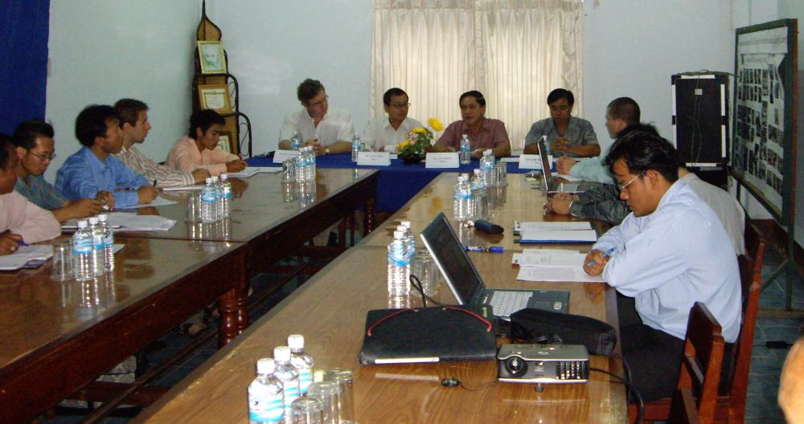
Multi-stakeholder meeting, Thakek

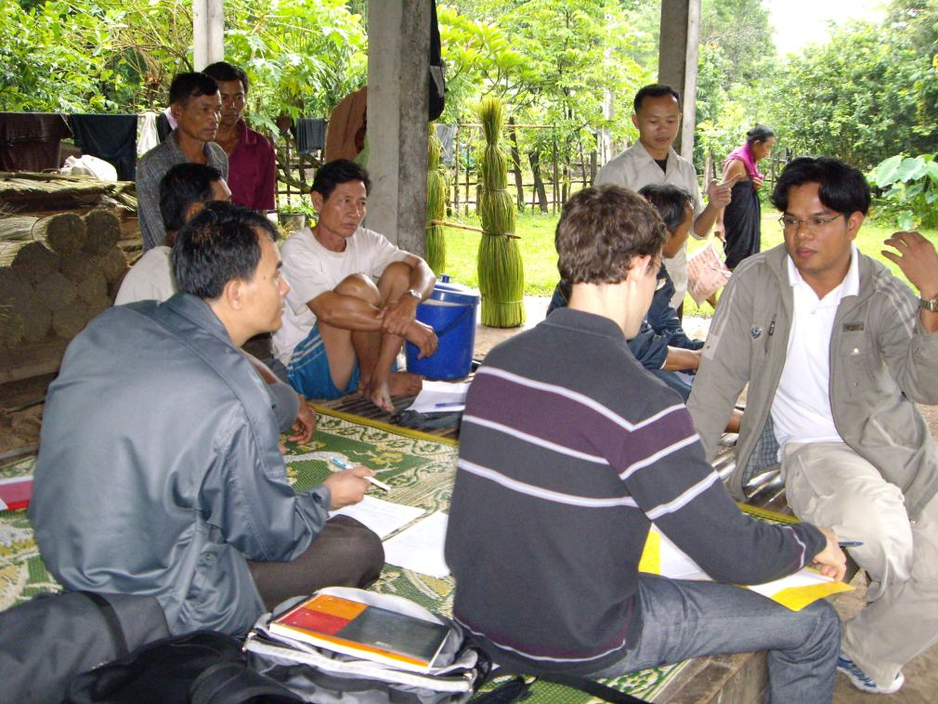
Survey test in Nonghoy village (Khammuon)

