Provincial level multi-stakeholder meeting and survey test, Kampong Cham (Cambodia), 28-29 Sept. 2007

A multi-stakeholder meeting with participants from planning, transport, health and education departments, MIME, EDC and EAC has been arranged in Kampong Cham province to present the CAP REDEO project and the objectives of its provincial implementation. Discussions followed to collect multisector data in the province. Complementary data on energy demand and renewable energy (biomass & hydro) potential will be obtained through a survey which has been tested in selected villages.

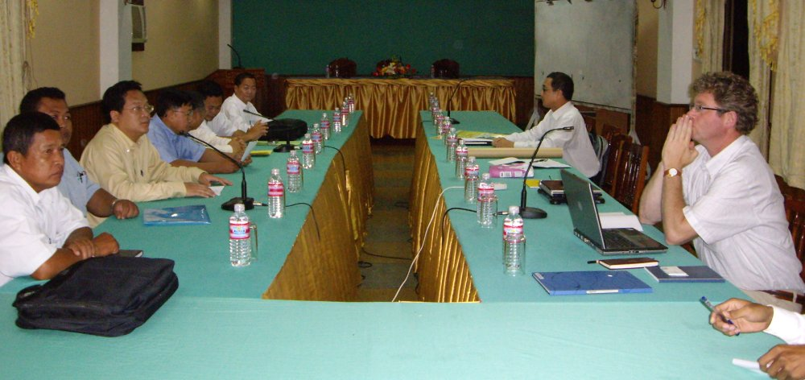
Multi-stakeholder meeting, Kampong Cham

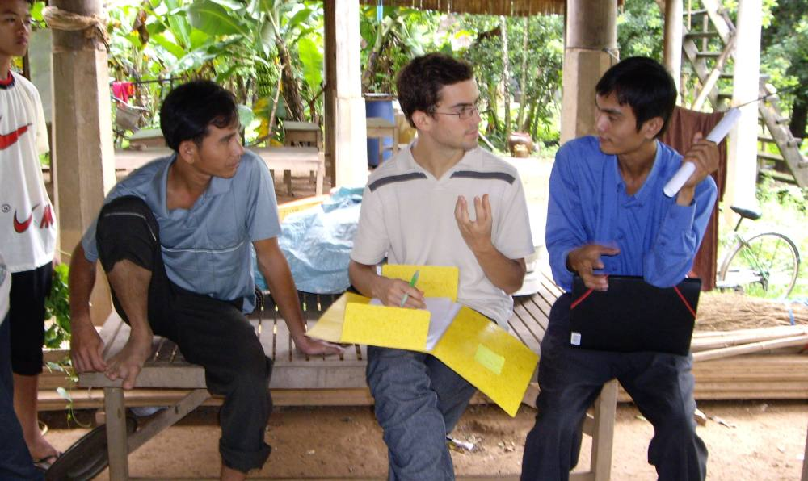
Survey test in Roang Leo village (Kampong Cham)

