National level multi-stakeholder meeting, Vientiane (Lao PDR), 11 Oct. 2007

A multi-stakeholder meeting with participants from planning, statistics, health and education departments, MOEM and EDL has been arranged in Vientiane to review the situation of rural electrification in Lao PDR and present our multi-criteria approach used in identification of high electrification priority areas. Suggested criteria and data collection issues have then been discussed.

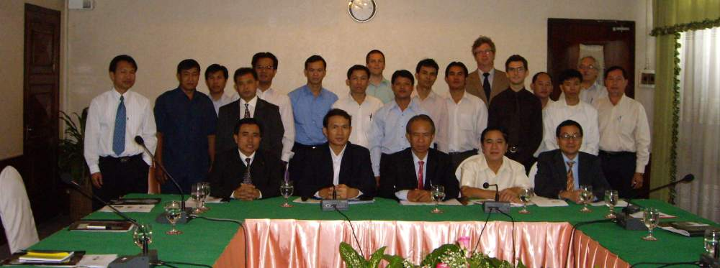
National multi-stakeholder meeting Vientian

