Distributed Energy Management Tools in Cambodia and Laos
Project Newsletter Number 1

Project Context
Rural Electrification is a key element of the development and poverty reduction strategies planned by the Governments of both Cambodia and Laos PDR. These two countries have very different electrification contexts, however one similarity is the crucial role being played by small private entrepreneurs. In both countries the Governments are encouraging these private interests to provide services in areas that will not be reached by government programs for some time, if at all.

These small rural entrepreneurs typically suffer from a lack of the technical capacity and business management skills needed to successfully operate a mini-grid service. Consequently rural communities often suffer from electricity services that are expensive, low quality and unreliable.

Objectives
To help improve access to higher quality and more reliable energy services to rural populations, by:
- providing Laos and Cambodia with tailor made software tools to ensure the sustainable operations of local mini grids and / or renewable energy systems.
- ensuring the long term sustainable operation (technical and managerial) of distributed renewable energy systems outside the main grid in Laos and Cambodia – hence increasing their penetration rate and acceptance;
- increasing the efficiency of distributed energy systems (technical and managerial) through loss reduction (technical and non technical), improved maintenance and operation thus improving the economic viability of these systems;
- contributing to the emerging of professional and well trained local – private – operators capable of efficiently running distributed renewable energy systems;
- developing institutional capability at the Ministerial / regulators level to formulate, implement and monitor the performance of private rural SMEs involved in distributed - renewable energy electrification

Project Partners
  - Innovation Energie Devellopement (IED) in France - Project Leader
  - Ministry of Industry, Mines and Energy in Phnom Penh (Department of Energy Planning), Cambodia
  - Electricite du Cambodge, Cambodia
  - Ministry of Industry and Handicrafts (Department of Electricity, Rural Electrification Division)
  - Power Dev in Belgium

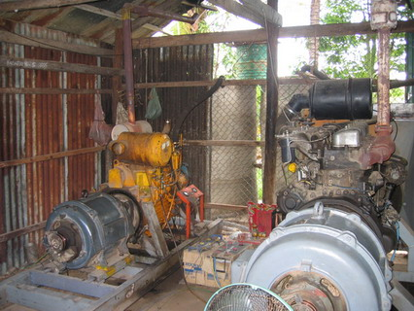

Project Activities
Kickoff Meeting – May 2005
The DEMT project was officially kicked-off on Thursday, May 19th, 2005 at the MIME Offices, Phnom Penh. This meeting was attended by 13 delegates representing the project partners, plus the Electricity Authority of Cambodia (an important stakeholder in the project). This was followed by a kickoff meeting in Lao PDR on Friday, May 20th, 2005 at MIH Offices, Vientiane. The meeting delegates also visited some villages electrified with Solar Home Systems as part of the World Bank’s recent “SPRE1” program.
The main output of the kickoff meetings was a good understanding among all partners of the project requirements, schedule and responsibilities. These were documented in a confirmed project schedule, partner responsibilities, budgets and consortium agreement.
One particularly important outcome was the decision to produce two different software tools, each customised to the actual situations in each country. Thus in Cambodia: a tool to help REEs manage their mini-grids, typically based on small diesel generations; and in Laos: a tool to help small rural sellers of Solar Home Systems such as those involve in the World Bank’s “SPRE1” project. All project partners agreed this would provide the greatest net benefit, but insisted that each country would participate in development and training of both tools because they would both be relevant for both countries in the longer term.
REE Management Survey – July 2005
A basic survey was conducted among a sample of licensed REEs in Cambodia to determine various aspects of their technical and management capacity and processes. This was conducted by MIME using both a written questionnaire and telephone interview. The sample size represented over 70% of all licensed REEs and therefore provided valuable data needed to design appropriate tools. The information ranged from the existing computer skills and ownership through to the procedures and systems used to manage customers and generations equipment. The main outputs of this survey was a Survey Report and a presentation of the results to delegates at the Specifications Review Workshop in July.
Specification Review Workshop – July 2005
In order to ensure that the tools developed would indeed be appropriate and effective, a draft Software Specification for the mini-grid and SHS tools were developed by IED with input from partners in Laos and Cambodia, based on the results of the context assessments in both countries. The draft specifications for both the Mini-Grid and SHS tools were presented to a range of delegates from both countries. These delegations included the project partners, plus other important stakeholders such as: electricity regulatory authority, actual REEs and NGOs involved in the sector. Following the workshop the draft specifications were updated to review feedback provided during the review workshops, and then circulated to all relevant stakeholders for further input. These two documents were then finalised and formed the main output of the Specification Review Workshop activities.

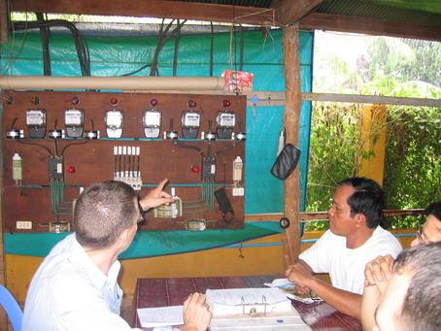

Coming Soon…
Intensive Software Testing and Training Session – January 2006
Project partners will nominate two delegates each to travel to the IED offices in France to work with the IED software developers in order to: i) validate the operation and outputs of the software tools; ii) test the software tools sample data from actual businesses in each country.
Remaining Project Steps
- Translation of Software Tools and User Manuals – January and February 2006
- Packaging of Provincial Power Generation Management Module for EDC in Cambodia – February 2006
- Pilot Installation and Testing – February 2006
- Training-of-Trainers – March 2006
- Training of Users (REEs in Cambodia and PESCOs in Lao PDR) – April and May 2006
- Issue Software and Subsidised PCs to Users – April and May 2006
- Follow-up and technical support – April to December 2006
- Final Workshop and Final Report – June 2006

For more information, please contact:
IED - Innovation Energie Développement
ied@ied-sa.fr
http://www.ied-sa.fr
http://www.ied-asean.com

Anjali SHANKER – Project Director
Tuan Nguyen – Team Leader

Disclaimer
This document has been produced with financial assistance of the European Community. The views expressed herein are those of the project team and can therefore in no way be taken to reflect the official opinion of the European Community.

